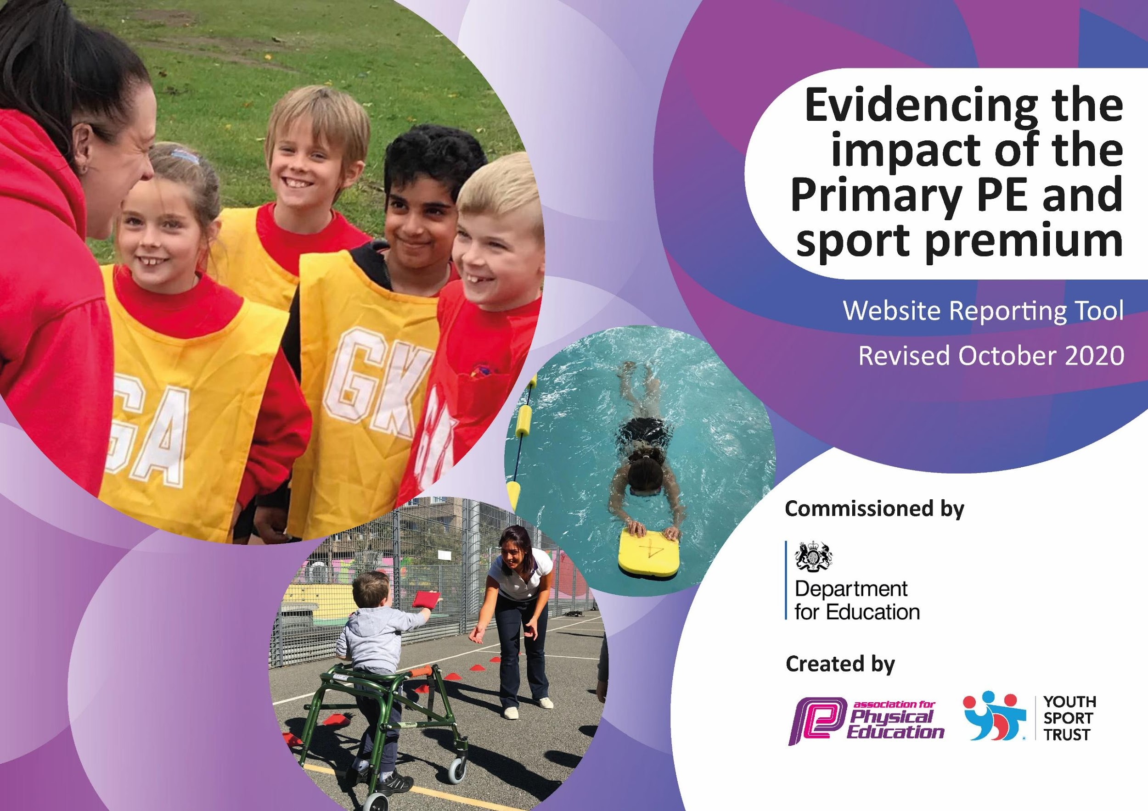
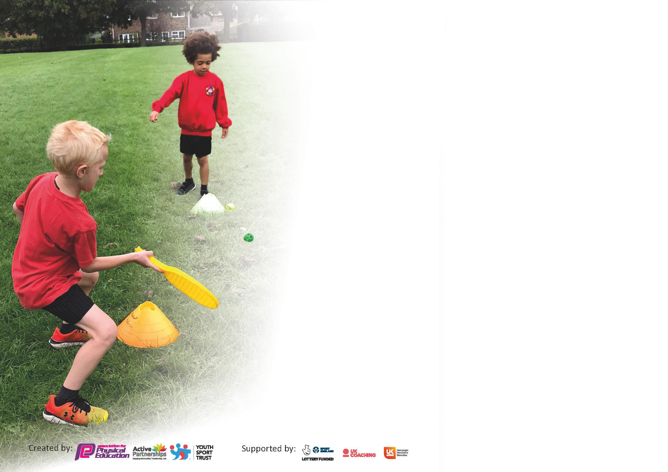

It is important that your grant is used effectively and based on school need. The Education Inspection Framework (Ofsted 2019 p64) makes clear there will be a focus on ‘whether leaders and those responsible for governors all understand their respective roles and perform these in a way that enhances the effectiveness of the school’.

Under the Quality of Education criteria (p41) inspectors consider the extent to which schools can articulate their curriculum (INTENT), construct their curriculum (IMPLEMENTATION) and demonstrate the outcomes which result (IMPACT).

To assist schools with common transferable language this template has been developed to utilise the same three headings which should make your plans easily transferable between working documents.

Schools must use the funding to make additional and sustainable improvements to the quality of Physical Education, School Sport and Physical Activity (PESSPA) they offer. This means that you should use
the Primary PE and sport premium to:

- Develop or add to the PESSPA activities that your school already offer
- Build capacity and capability within the school to ensure that improvements made now will benefit pupils joining the school in future years

Please visit gov.uk for the revised DfE guidance including the 5 key indicators across which schools should demonstrate an improvement. This document will help you to review your
provision and to report your spend. DfE encourages schools to use this template as an effective way of meeting the reporting requirements of the Primary PE and sport premium.

We recommend you start by reflecting on the impact of current provision and reviewing the previous spend.

Schools are required to publish details of how they spend this funding as well as on the impact it has on pupils’ PE and sport participation and attainment by the end of the summer term or by 31st July 2021 at the latest.

** In the case of any under-spend from 2019/20 which has been carried over this must be used and published by 31st March 2021.

We recommend regularly updating the table and publishing it on your website throughout the year. This evidences your ongoing self-evaluation of how you are using the funding to secure maximum, sustainable impact. Final copy must
be posted on your website by the end of the academic year and no later than the 31st July 2021. To see an example of how to complete the table please click HERE.
Created by: Supported by:

Please note: Although there has been considerable disruption in 2020 it is important that you publish details on your website of how you spend the funding - this is a legal requirement.

Support for review and reflection - considering the 5 key indicators from DfE, what development needs are a priority for your setting and your pupils now and why? Use the space below to reflect on previous spend and key achievements and areas for development.

N.B. In this section you should refer to any adjustments you might have made due to Covid-19 and how these will influence further improvement.
Key achievements to date until July 2020: | Areas for further improvement and baseline evidence of need:
Consistent teaching of PE across the school.  PE instructor has completed Level 3 and Level 4 qualifications.  Pupils given the chance to try a wide range of After School activities: Fencing, Archery, Table Tennis | Development of activities for use during lunch time.  Development of MSA supervising lunchtimes – skills needed in running activities and games.  Swimming - increase the number of children swimming 25m by the end of Year 6  Engage more children to participate in extra- curricular clubs by 30%.

Did you carry forward an underspend from 2019-20 academic year into the current academic year? NO * Delete as applicable

If YES you must complete the following section
If NO, the following section is not applicable to you

Meeting national curriculum requirements for swimming and water safety.

N.B Complete this section to your best ability. For example you might have practised safe self-rescue
on dry land.
What percentage of your current Year 6 cohort swim competently, confidently and proficiently over a distance of at least 25 metres?  N.B. Even though your pupils may swim in another year please report on their attainment on leaving primary school at the end of the summer term 2020. | 32%
What percentage of your current Year 6 cohort use a range of strokes effectively [for example, front crawl, backstroke and breaststroke]? | 32%
What percentage of your current Year 6 cohort perform safe self-rescue in different water-based situations? | Not assessed prior to Covid
Schools can choose to use the Primary PE and sport premium to provide additional provision for swimming but this must be for activity over and above the national curriculum requirements. Have you used it in this way? | Yes for pupils in our SRB to build their confidence with swimming.

Action Plan and Budget Tracking
Capture your intended annual spend against the 5 key indicators. Clarify the success criteria and evidence of impact that you intend to measure to evaluate for pupils today and for the future.

Academic Year: 2020/21 | Total fund allocated: £17810 | Date Updated: March 2021
Key indicator 1: The engagement of all pupils in regular physical activity – Chief Medical Officers guidelines recommend that primary school pupils undertake at least 30 minutes of physical activity a day in school |  |  |  | Percentage of total allocation:
 |  |  |  | %
Intent | Implementation |  | Impact | 35% £6539
Your school focus should be clear what you want the pupils to know and be able to do and about  what they need to learn and to  consolidate through practice: | Make sure your actions to achieve are linked to your intentions: | Funding allocated: | Evidence of impact: what do pupils now know and what can they now do? What has changed?: | Sustainability and suggested next steps:
Sports clubs to be run every day after school, so that each year group has access to at least one club. | Sports instructor to run after school clubs - 4 hours per week (summer term - 14 weeks)  CSF sports clubs for Summer Term - 3 sessions per week for 14 weeks and 3 weeks in spring term -  Tennis club funded by school for summer term. | £1,047  £2040  £250 | Pupils feedback about what they learnt/enjoyed from after school clubs. Pupil voice is used to recruit pupils to clubs from Autumn 2021
All children from the SRB to access  swimming  - | Book separate sessions over a period of 6 weeks for the children to go as a class so all children can access swimming  £90 | £90 | Children will have specific swimming lessons which will boost their  confidence not just in water but in other aspects of school  SRB children will be confident and able to access the  swimming lessons with their  mainstream year  group
For pupils to have equipment that engages them in healthy outdoor activities during lunchtime. | Sports instructor to order and then share out between the classes equipment for outdoor play. | £3000  (£1,921.35 spent by Spring 2021) | Children are observed to be joining in and taking part in healthy outdoor activities during lunch time.  Increased engagement means fewer behaviour incidents at lunchtime.
Key indicator 2: The profile of PESSPA being raised across the school as a tool for whole school improvement |  |  |  | Percentage of total allocation:
 |  |  |  | %
Intent | Implementation |  | Impact | 14% £2426.67
Your school focus should be clear what you want the pupils to know and be able to do and about  what they need to learn and to  consolidate through practice: | Make sure your actions to achieve are linked to your intentions: | Funding allocated: | Evidence of impact: what do pupils now know and what can they now do? What has changed?: | Sustainability and suggested next steps:
Pupils to have the opportunities to participate in a range of inclusive and varied sporting activities. | Join Norwich School Sports Partnership.  This membership includes access to Sports Leaders training  Bikeability training | £2,426.67 | During pupil voice surveys at the end of the academic year, pupils will be able to talk about the activities they took part in and what they learnt from them.

Key indicator 3: Increased confidence, knowledge and skills of all staff in teaching PE and sport |  |  |  | Percentage of total allocation:
 |  |  |  | %
Intent | Implementation |  | Impact | 12%
Your school focus should be clear | Make sure your actions to | Funding | Evidence of impact: what do | Sustainability and suggested
what you want the pupils to know | achieve are linked to your | allocated: | pupils now know and what | next steps:
and be able to do and about | intentions: |  | can they now do? What has
what they need to learn and to |  |  | changed?:
consolidate through practice:
To upskill the sports instructor, so that he delivers the best quality PE lessons possible. | Sports Instructor to take part in Level 5 instructor course. | £985 | Sports instructor to evaluate impact on his teaching at the end of the course.
For teachers to be upskilled in their PE delivery by observing and team teaching with the specialist PE SPORTS INSTRUCTOR once a half term. | Specialist PE SPORTS INSTRUCTOR to team-teach and mentor class teachers on a timetabled basis once a half term. | £1120 | Teachers teach one hour of PE a week, and the SPORTS INSTRUCTOR teaches the other. In the hour of delivery by teachers, their confidence, knowledge and skills are improved.  SPORTS INSTRUCTOR to gather evidence of improvements.
Key indicator 4: Broader experience of a range of sports and activities offered to all pupils |  |  |  | Percentage of total allocation:
 |  |  |  | %
Intent | Implementation |  | Impact | 20%
Your school focus should be clear | Make sure your actions to | Funding | Evidence of impact: what do | Sustainability and suggested
what you want the pupils to know | achieve are linked to your | allocated: | pupils now know and what | next steps:
and be able to do and about | intentions: |  | can they now do? What has
what they need to learn and to |  |  | changed?:
consolidate through practice:
As above for Norwich SSP
For MSAs to be able to deliver and engage pupils in a range of outdoor activities at lunchtimes. | Sports instructor to deliver CPD to MSAs about games that they can lead the pupils in at lunchtimes. Sports Instructor to be outside at lunchtimes and offering modelling of how to do this for MSA. | £3,644.00 | Children are observed to be joining in and taking part in healthy outdoor activities during lunch time.  Increased engagement means fewer behaviour incidents at lunchtime.
Additional achievements:

Key indicator 5: Increased participation in competitive sport |  |  |  | Percentage of total allocation:
 |  |  |  | %
Intent | Implementation |  | Impact | 18%
Your school focus should be clear | Make sure your actions to | Funding | Evidence of impact: what do | Sustainability and suggested
what you want the pupils to know | achieve are linked to your | allocated: | pupils now know and what | next steps:
and be able to do and about | intentions: |  | can they now do? What has
what they need to learn and to |  |  | changed?:
consolidate through practice:
For children to take part in competitive sports activities, in a non-selective way. | During pandemic - As pupils cannot compete competitively with other schools currently, we will buy in sports organisation to run competitions within year groups within the summer term.  The funding aims to allow for at least one day’s worth of competitive activities per year group. | £2200 | Pupils can explain what they got from the experience of competing, what they learnt, what they found hard.  SPORTS INSTRUCTOR to gather pupil voice after events.
If the pandemic allows, pupils to take part in football matches and City Sports events. | -sports instructor to sign up for SSP events and organise other events and complete the admin for visits and events (2 hr a week admin)  Join the Primary School Football League for Year 5 7v7. | £729 for half of the year.  £300 overtime for associate staff to attend external events as second adult | Pupils report positive experiences of competing with other schools; they demonstrate a sense of pride and sportsmanship.  Sports instructor to gather pupil voice after events.

